11IT2 Example Testing Table
Input | Expected output | Actual output | Passed?
Any name e.g. Mr Smith | Accepts name, returns name as Mr Smith | 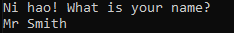 | ☒
No name – empty string | Accepts name, leaves name line blank | 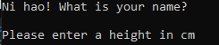 | ☒
Height of 99 | Invalid input. Please enter a whole number between 100 and 250 inclusive, e.g. 158. |  | ☒
Height of 100 | Accepts height: Please enter a height in cm. | 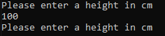 | ☒
Height of 101 | Accepts height: Please enter a height in cm. | 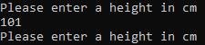 | ☒
Height of 249 | Accepts height: Please enter a height in cm. | 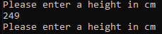 | ☒
Height of 250 | Accepts height: Please enter a height in cm. | 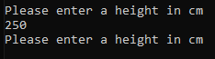 | ☒
Height of 251 | Invalid input. Please enter a whole number between 100 and 250 inclusive, e.g. 158. |  | ☒
No height – empty string | Invalid input. Please enter a whole number between 100 and 250 inclusive, e.g. 158. |  | ☒
Invalid height – 210.5 | Invalid input. Please enter a whole number between 100 and 250 inclusive, e.g. 158. |  | ☒
Invalid height – one hundred | Invalid input. Please enter a whole number between 100 and 250 inclusive, e.g. 158. |  | ☒
Correct range of heights: 136, 146, 153, 158, 160, 168, 169, 181, 187 | Mr Smith, min was 136, max was 187 and the mean was 162. That is 30 above the national average. | 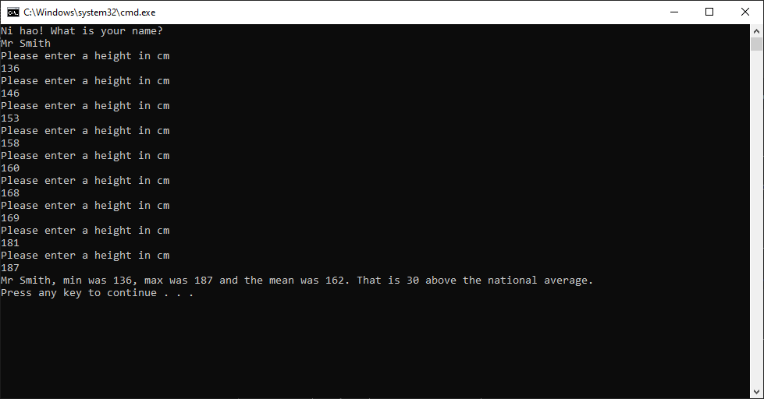 | ☒
Alternate correct range of heights: 177, 198, 219, 188, 122, 143, 121, 153, 124 | Mr Smith, min was 121, max was 219 and the mean was 160.555555555556. That is 28.5555555555555 above the national average. |   

